Directions: Copy both the diagram and sentences below. Analyze the picture and fill in the blanks.

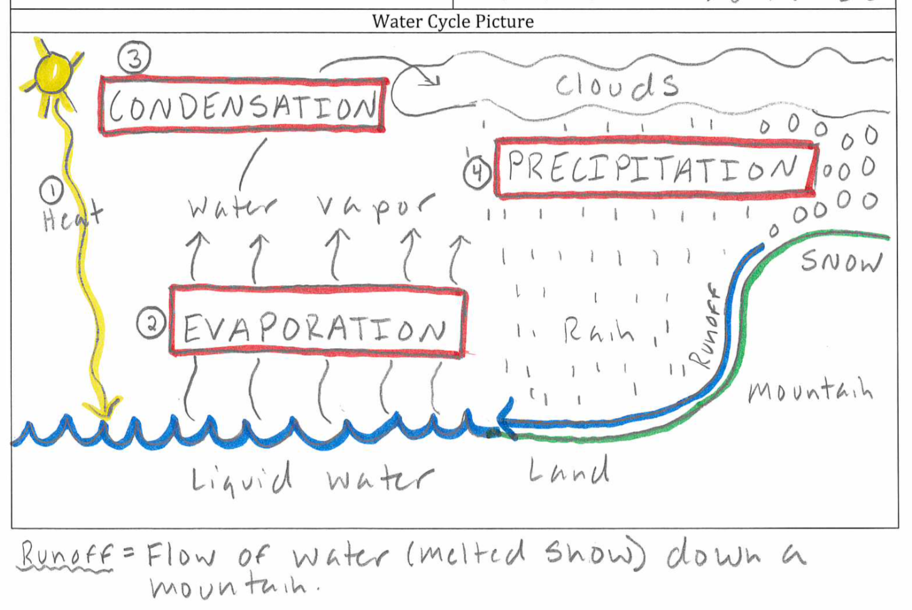

- The _____________cycle is when water moves around Earth in its different phases (solid, liquid, and _________________).
- Liquid water in the ocean heats up and turns to water ______________ through the process of ___________________________.
- Water vapor cools turns back to liquid water and forms ______________ through the process of _________________________.
- When clouds become too heavy with water they release through the process of _____________________________.
- Snow melting and flowing down a mountain is called _____________________, which forms ______________.
- All rivers eventually slow into the ______________________.

