Directions: Copy the picture and sentences below. Analyze the picture and fill in the blanks!

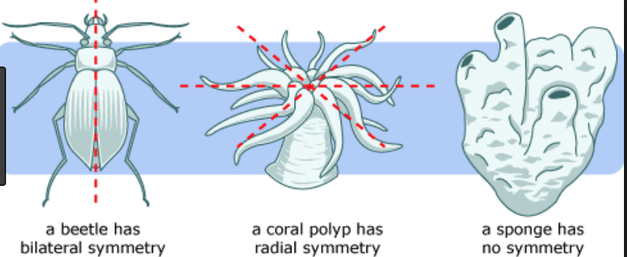

- ______________________ symmetry is when each side (top, bottom, and sides) is the same.
- ______________________ symmetry is when an organisms left and right side are the same.
- _______________________symmetry is when the organism has no sides that are the same!
- A whale has ____________________ symmetry.
- A starfish has __________________ symmetry.

