Directions:
- Copy the picture and key. MUST COLOR.
- Copy the sentences.
- Analyze the picture and fill in the blanks.

Range of Tolerance: An organism’s ability to survive environmental change.

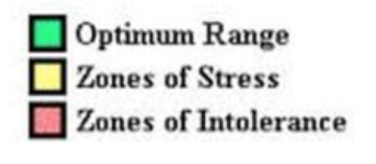
Beta Fish
Range of Tolerance Graph
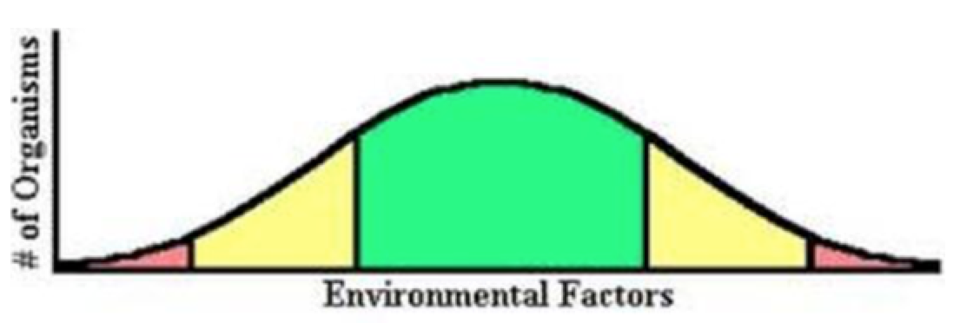
50° F 55°F 65°F 80°F 85°F 90°F

- Give examples of environmental factors (must be non-living) affecting a marine organism:
- ____________________________
- ____________________________
- ____________________________
- The graph shows an example of a ___________ range of tolerance to ________________________.
- A beta thrives in this temp range: ______________ to _________________.
- A beta’s body becomes stressed when temps lower to ____________ and exceed ___________.
- Most betas will die in temps lower than ___________________ and exceeding ____________.

