Part 2: Measuring mass with triple beam balances and temperature using a thermometer.

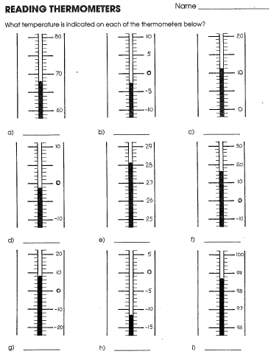 | 