Directions:
- Copy everything below.
- Read the article.
- Think of at least 3 examples for each box.

Limiting Factor: When an environmental condition is NOT ideal for survival!

Graph | Blactail Shinner Limiting Factors
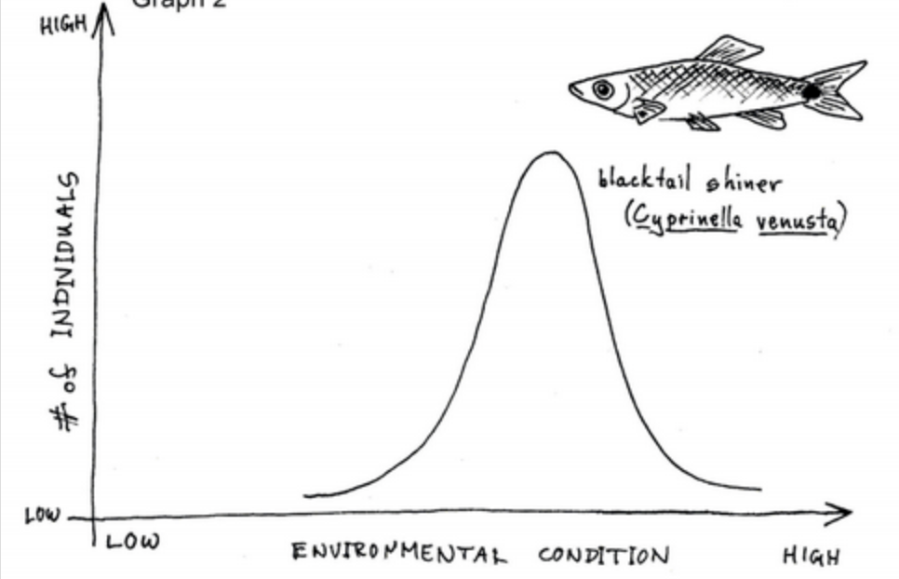

Adaptation: Any trait allowing an organism to survive in an area.

Frog  Adaptations | Frog Environment’s  Limiting Factor(s)

