Directions:
- Copy pie chart and sentences below.
- Read the article.
- Fill in the blanks.

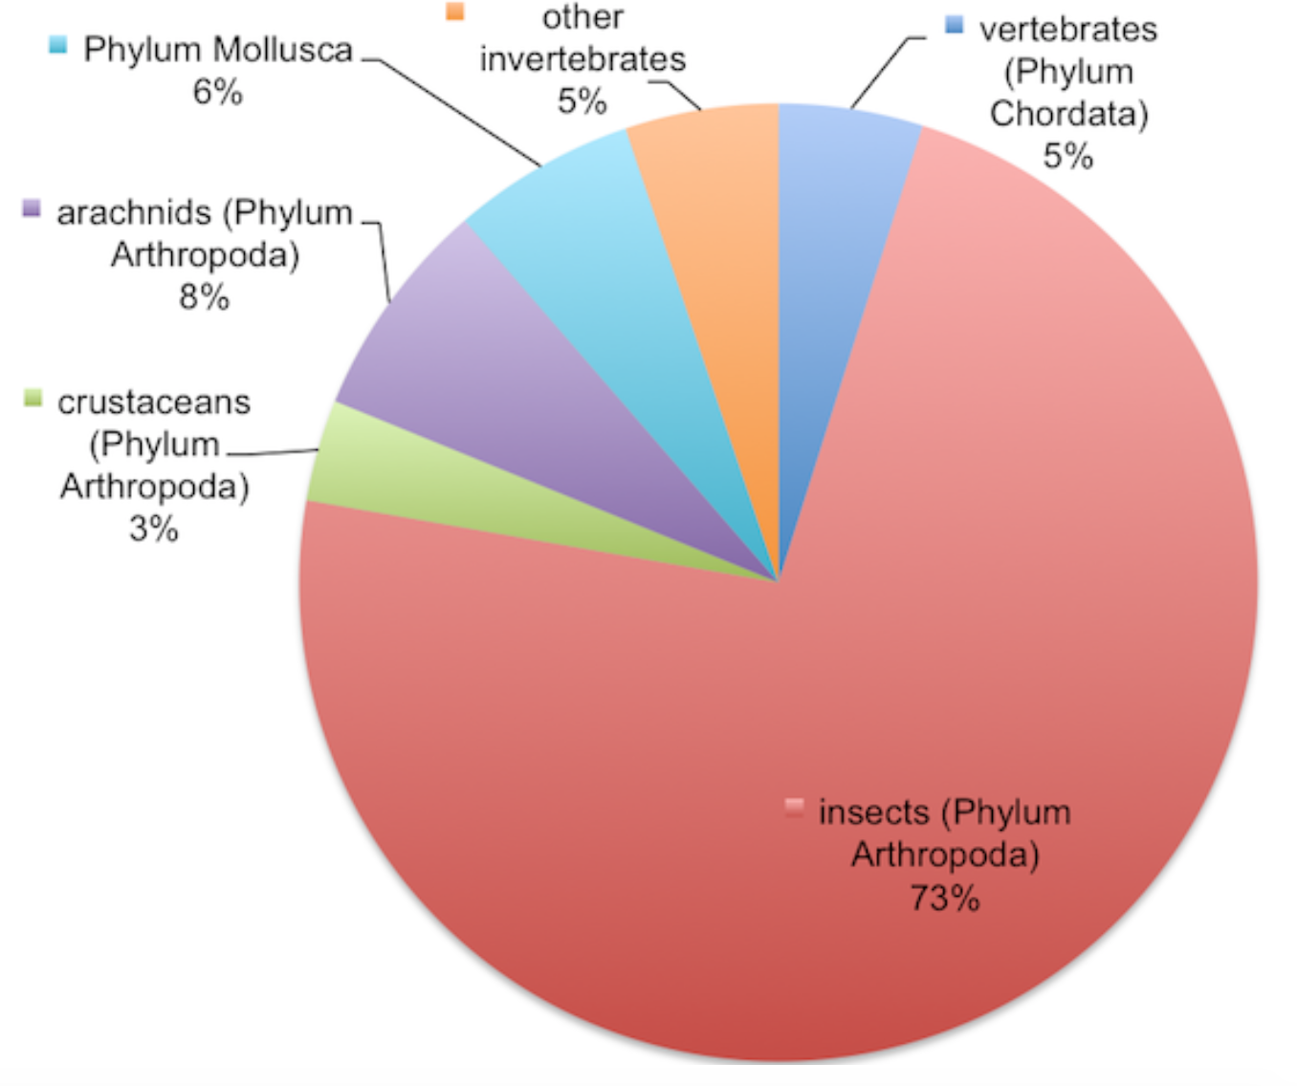

- Most people when asked about animals will name a ________________________, such as birds, mammals, reptiles, and fish.
- However, the vast majority of species on Earth are ______________________ (animals without a backbone).
- Only ________% of animals on Earth are vertebrates, the rest are ________________________.
- There are _______________ total animal phylum and insects (aka _____________________ phylum) account for the highest number of species.
- Scientists estimate approximately _____________ million animal species exists today.

