Directions: Copy the picture, and sentences. Analyze the picture and fill in the blanks!

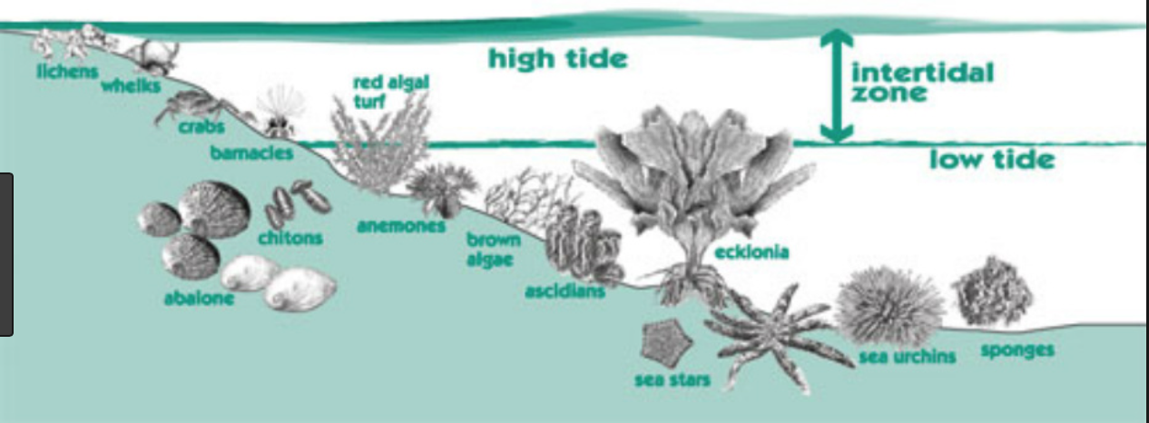

- Water level on the beach is constantly changing because of _________________.
- The area between high and low tide is called the __________________________________.
- List three organisms that are always covered in
- ______________________
- ______________________
- ______________________
- List three organism that are sometimes covered in water:
- ______________________
- ______________________
- ______________________
- List three organisms that live underneath the sand:
- ______________________
- ______________________
- ______________________

