Directions: Copy the picture and sentences below. Use the knowledge you gained yesterday from the Building Coral Reefs Activity to help you answer the questions.

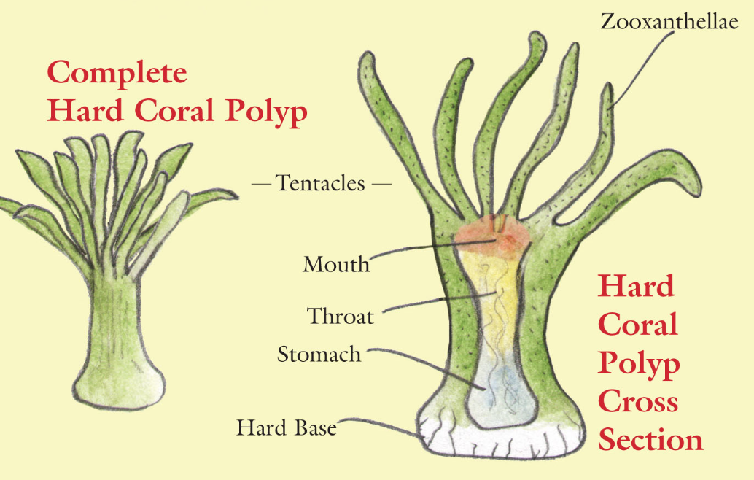

- The diagram above shows an individual ______________________.
- The picture on the left shows a _____________________ polyp.
- The picture on the right shows a polyp cut in __________________.
- The ______________________ capture food and also contains the photosynthetic _______________________ organism.
- Coral reefs contain __________________________ polyps.

