Directions: Draw and label the picture and copy the sentences. Analyze the picture and fill in the blanks!

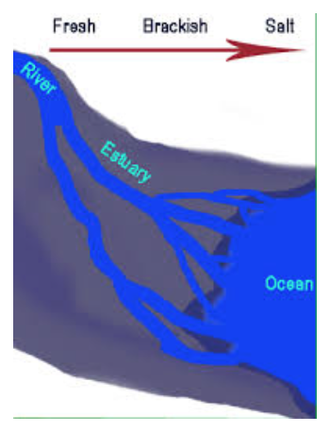

- All water has some level of ________________, even freshwater.
- An estuary is where a river and ocean _________________.
- Another name for salinity is ______________________.
- The level of salt ______________________throughout the estuary.
- Salinity ________________________ in water closer to the ocean and ____________________ closer to the river.
- Estuary organisms have a _____________________ salinity range of tolerance.

