Directions
- Copy everything below.
- Read article.
- Analyze article and fill in the blanks.

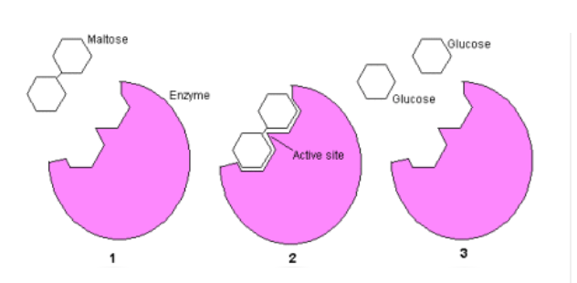

- Your cells are a little bag full of ________________________.
- Enzymes help _______________ up these chemical reactions.
- Maltase is one example of an enzyme and it converts ________________into ________________.
- The chemical reaction can be written as:
_____________________________ → _______________ + _______________
- The enzyme’s ____________________ has the same shape as the molecule it will break down.
- Individuals that are lactose intolerant are missing the _______________ enzyme.

